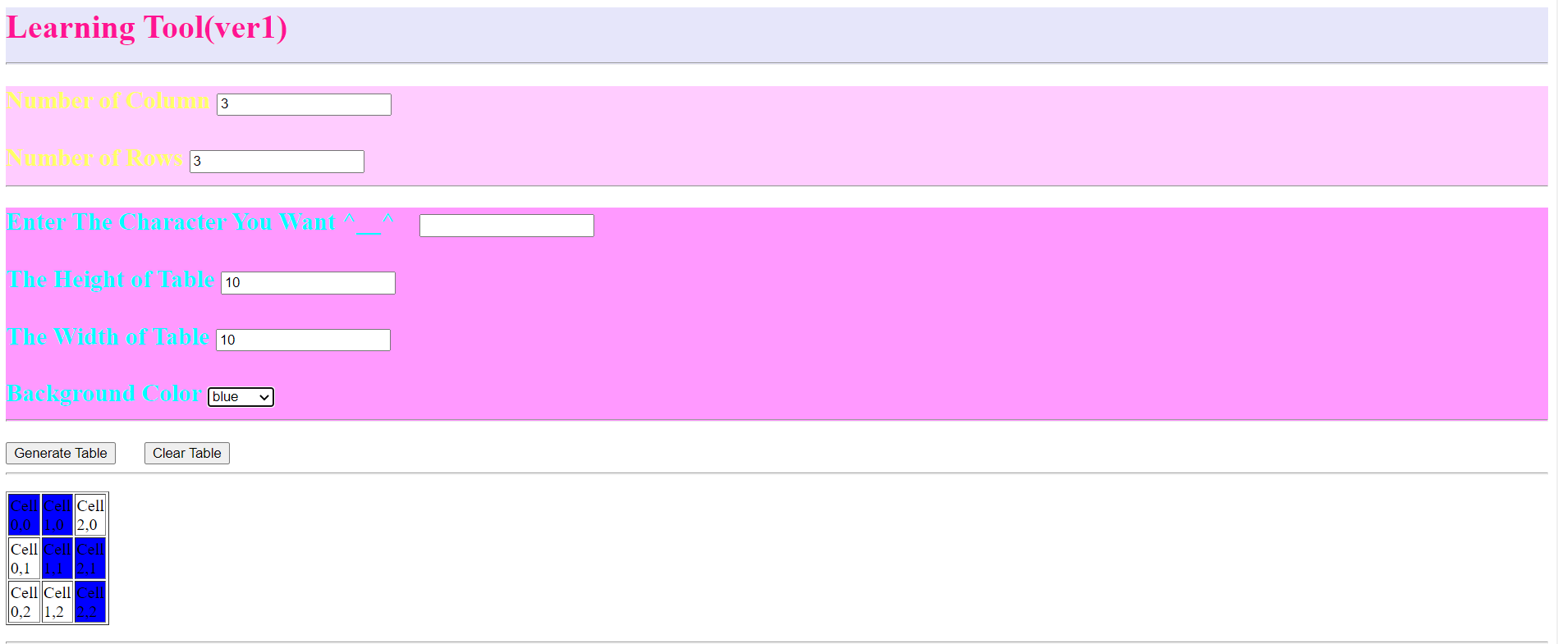

Generate a table with by COLUMN \* ROWS, when the user hovers over the cells the background color of cells will be changed.